Customer Integration Scope

|  |  |
| --- | --- |
|  |  |
| Customer | Sandvik |
| Customer On Premise / Online? | Onsite |
| Primary Contact (Requester) | udaykiran.yelamanchili@sandvik.com <udaykiran.yelamanchili@sandvik.com> |
| IT Contact / Email (if applicable) |  |
|  |  |
| Customer Software | Verian |
|  |  |
| Implementation Consultant | Andrew Gafken |
| Deliver Code To | Customer |
| Date (and revision) | 7/19/2016 |

# *Overview*

*The integration between Verian and MC will allows for the flow of order request details to export from Maintenance Connection and Maintimizer and import into the Verian system to reduce double data entry in two system. It will also allow for the flow of purchase order receipt details to export from the Verian system and import into Maintenance Connection and Maintimizer.*

* Export 1: MC to Verian
* Import 1: Verian to MC

# Export 1: MC to Verian

## Description

*The Shopping Cart import allows for the flow of order request details to export from the Maintenance Connection and Maintimizer and import into the Verian system to reduce double data entry in two systems. This is a totally manual process, so the user will create the PO, and then need to have the ability to generate a Pipe Delimited file for the PO. Which at that point they will manually upload that file into Shopping Cart.*

* **MC Data:** *Purchase Orders*
* **Customer Software System:** *Purchase Orders*

## Integration Method

* **Method To Be Deployed:** *File*

### File Based

|  | **Customer Value** | ***Instructions*** |
| --- | --- | --- |
| **Type** | Pipe Delimited |  |
| **Frequency** | On demand | *User needs to be able to generate a Pipe Delimited file for any PO they create* |
| **Record Export Trigger** | Upon clicking a generate button | *Or some sort of button that will allow them to download a pipe delimited file* |
| **Record Export Criteria** | That specific PO |  |
| **File Update Method** | n/a |  |
| **File Cleanup Method/Timing** | n/a |  |
| **Naming Convention** | Normal naming |  |
| **Header Row Included** | Yes |  |
| **File Destination**  (Onsite Customers Only) | n/a |  |

## Export Structure

* **Type:** *Record Based*

## Field List

| # | Field Description | MC Field Name | Customer SW Field | MC Field Type / Length | Default Value | Notes |
| --- | --- | --- | --- | --- | --- | --- |
| 1 | ItemSKU | PurchaseOrderDetail.PartID |  | Varchar-20 |  |  |
| 2 | ItemName | |  | | --- | | PurchaseOrderDetail.PartName | |  | |  | Varchar – 50 |  |  |
| 3 | OrderQuantity | PurchaseOrderDetail.OrderUnitQty |  | Int – 4 |  |  |
| 4 | Unit | PurchaseOrderDetail.OrderUnits |  | Varchar – 25 |  |  |
| 5 | VendorName | PurchaseOrder.VendorName |  | Varchar – 50 |  |  |
| 6 | UnitCost | PurchaseOrderDetail.OrderUnitPrice |  | Money – 8 |  |  |
| 7 | ItemCategory | Part.CategoryID |  | Varchar – 25 |  |  |
| 8 | Manufacturer | Part.ManufacturerID |  | Varchar – 25 |  |  |
| 9 | AccountCode | PurchaseOrderDetail.AccountID |  | Varchar - 100 |  |  |

## Special Instructions

*Since this will be a manual export, we need to include an export Pipe Delimited button on the details tab of the PO. This will allow the user to click the button to export the pipe delimited file.*

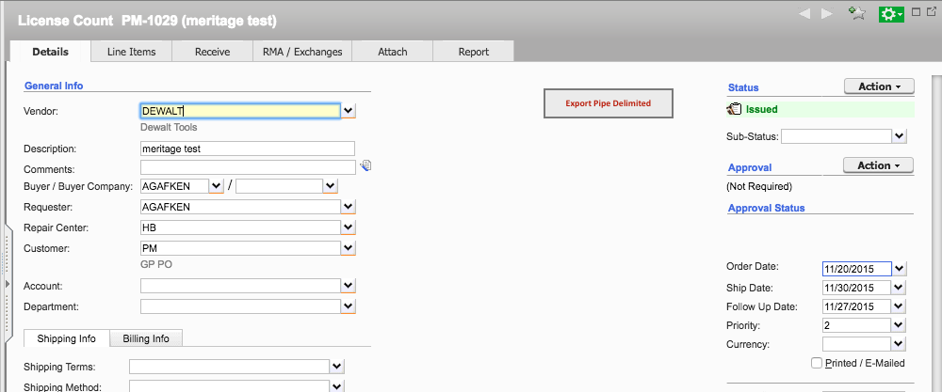

# Import 1: Verian to MC

Important Note: Prior to beginning the development of any import into MC v6.0, the customer must provide a sample data file that represents the conditions being imported and tested. If a sample data file is not provided to Maintenance Connection within one week of project approval, the committed customer delivery date will be extended.

## Description

*The Receiving Export allows for the flow of purchase order receipt details to export from the Verian system and import into Maintenance Connecton and Maintimizer.*

* **MC Data:** *Purchase Orders*
* **Customer Software System:** *Purchase Orders*

## Integration Method

* **Method To Be Deployed:** *File*

### File Based

|  | **Customer Value** | ***Instructions*** |
| --- | --- | --- |
| **Type** | pipe-delimited flat file |  |
| **Frequency of MC Import** | Daily – 4:00am UTC |  |
| **File Update Approach** | New file each time |  |
| **File Cleanup Method/Timing** | File management is normally maintained by the customer. |  |
| **File Name** | Datetime stamped |  |
| **Header Row Included** | yes |  |
| **File Placement and Retrieval Method** | The file we be placed in a designated location by Verian from which the CLIENT will import the file. The location will be a SFTP server setup by Verian. |  |

## Import Structure

* **Type:** *Record Based*

## Field List

***Purchase Orders***

| H/L | Field Description | MC Field Name | Customer Fields (name, column) | Field Type / Length | Default Value | Notes and Error Trapping |
| --- | --- | --- | --- | --- | --- | --- |
| H | PO Number | PurchaseOrder. PurchaseOrderID | REQ.ReqNum | Text - 25 |  |  |
| H | PO Total  Total Header | PurchaseOrder.Total |  | Money - 8 |  |  |
| H | ReceivedTotal |  |  |  |  | Disregard this field |
| L | VendorName |  |  |  |  | Disregard this field |
| L | ItemName | PurchaseOrderReceive.ItemName |  | Varchar – 50 |  |  |
| L | ItemSKU | PurchaseOrderReceive.ItemID |  | Varchar – 25 |  |  |
| L | UnitCost | PurchaseOrderReceive.OrderUnitPrice |  | Money – 8 |  | Should update the price of the item not only on the Receipt, but Line Item price, and Last Ordered Price on the Item details. |
| L | ItemDesc |  |  |  |  | Disregard this field |
| L | POLineID | PurchaseOrderDetail.LineItemNo |  | Int – 4 |  |  |
| L | OrderQuantity | PurchaseOrderReceive.OrderUnitQtyOrdered |  | Int – 4 |  |  |
| L | ReceivedQuantity | PurchaseOrderReceive.OrderUnitQtyReceived |  | Int – 4 |  |  |

## Record Handling

*Describe how each record will be handled. For example:*

* *Indicate the key field for record matching.* ***PO #*** */* ***ItemID***
* *Describe the behavior if the record does not exist (based on key field). Reject record and add to error report*

## Error Trapping

Typical error handling includes writing to a log file or database table with the associated failure message. At a minimum, this log file will include:

* Fail/Success Message for Import as a Whole
* Rejected/Failed Records
* Additional Error Messages as Outlined by Customer in the Field Listing Section

*Indicate any additional record level error trapping that you need logged.*

## Special Instructions

Note that the PO Total is all Line Items plus Tax & Freight – which may not equal the sum of the Extended Cost of the Line Items. Item Description would be passed if include in Verian. Set Bin to the Part Stock Room Bin#